Financial Services, Investment Advice & Insurance

BNZ Commercial Partner
Tim Conder
Ph: 838 6324
Mobile: 021 921 181
Tim_conder@bnz.co.nz

Andrew Flexman
Investment Advisor
M: +64 27 499 5980
P: +64 7 823 0805
TF: 0800 367 227
48 Empire Street, Cambridge
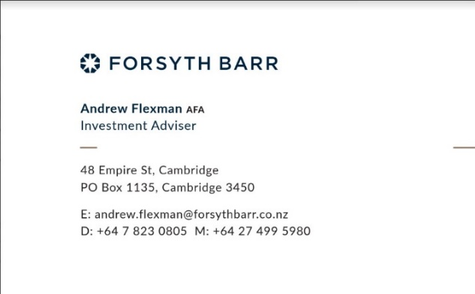

VAHRY INSURANCE
www.vahry.co.nz
- Waikato’s award winning and leading life and health insurers.
- health insurers for staff & business owners
(07) 849 1828 or 0272564081
Julia@vahry.co.nz

KEN WILLIAMSON CSTJ; QSM; CFINSTD
EXECUTIVE BROKER
+64 7 957 8602 | +64 21 829 978 | crombielockwood.co.nz
ken.williamson@crombielockwood.co.nz
Level 4, Bridgewater Building, 130 Grantham Street Hamilton
PO Box 1395 Hamilton 3240
+64 7 957 8600

